Term |  | Term 1 |  | Term 2 |  | Term 3
Reception | Driver project | 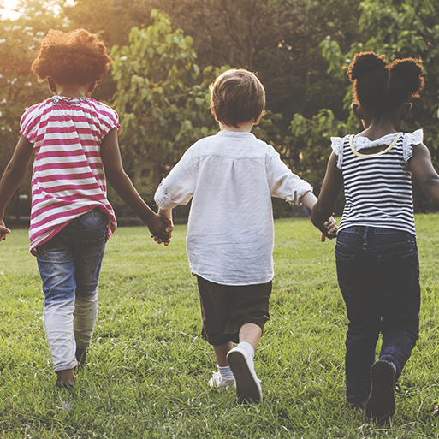  Me and My Community | 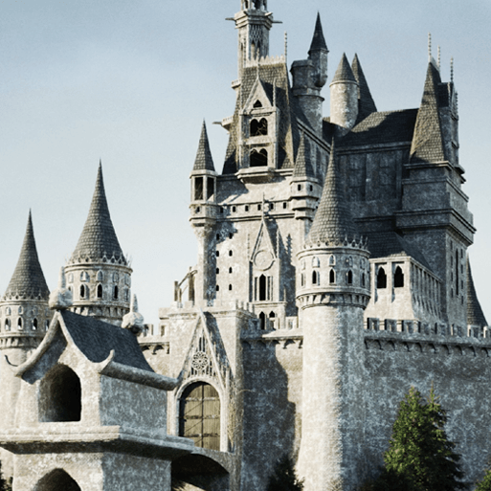  Once Upon a Time |   Starry Night | 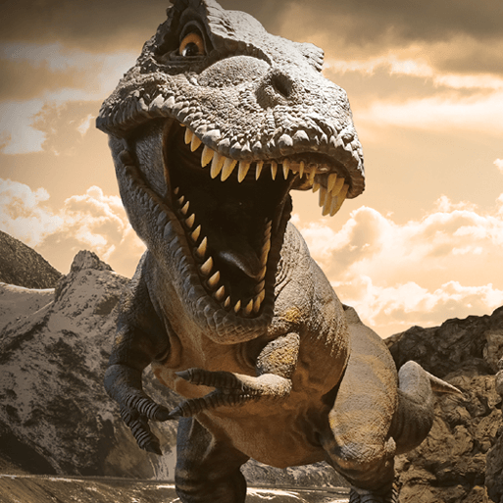  Dangerous Dinosaurs | 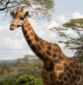  Animal Safari | 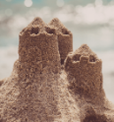  On the Beach
Reception | Mini project |   Exploring Autumn |   Sparkle and Shine | 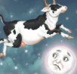  Stories and Rhymes | 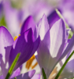  Signs of Spring | 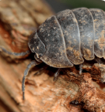  Creep, Crawl and Wriggle |   Move it, moving on
Reception | PSHE | Me and My Relationships | Valuing Difference | Keeping Safe | Rights and Respect | Being my Best | Growing and Changing
Reception | Forest school |  |  |  | Thursday morning: 10.30-12 | Thursday afternoon: 1.10-3.10pm | Thursday afternoon: 1.10-3.10pm

Main theme |  |  | History |  |  | Geography |  |  | History
Year 1/2 | Driver project |  | 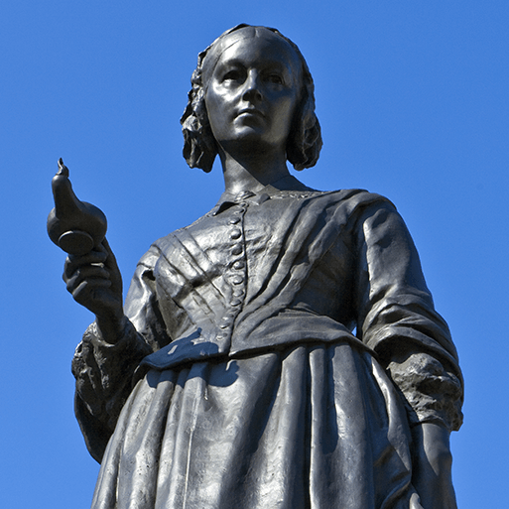  Movers and Shakers |  |  | 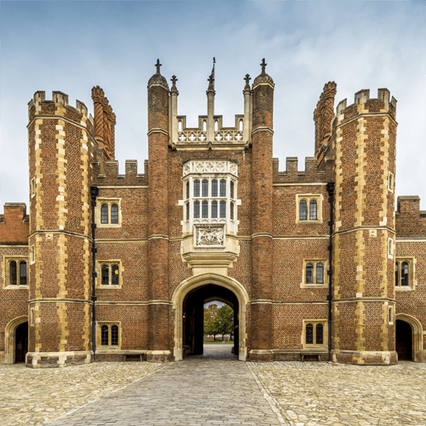  Magnificent Monarchs |  |  | 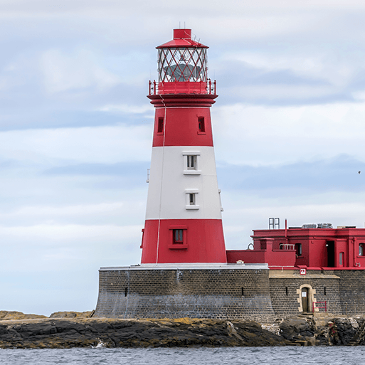  Coastline
Year 1/2 | Afternoon read |  | Rosa Parks |  |  | Queen Victoria’s Bathing Machine |  |  | Katie Morag and the New Pier
Year 1/2 | Subject-specific projects | Geog | Let's explore the world Part 1  Engage |  |  | Let's explore the world Part 1  D1/D2 Innovate |  |  | Covered in main project
Year 1/2 | Subject-specific projects | Science | Human survival |  | Habitats | Uses of materials |  | Plant survival | Animal survival
Year 1/2 | Subject-specific projects | Art |  |  | Exploring Colours | Portraits and poses |  |  | Flowerhead
Year 1/2 | Subject-specific projects | DT | Remarkable recipes |  |  |  |  | Push and Pull |  |  | Beach Hut
Year 1/2 | Subject-specific projects | RE | Christianity |  |  | Islam |  |  | Judaism
Year 1/2 | Subject-specific projects | Music | Dance, sing and play |  |  | Exploring Sounds |  |  | Exploring Improvisation
Year 1/2 | Subject-specific projects | Computing | Technology Around Us |  |  | Digital Photography |  |  | Robot Algorithms
Year 1/2 | Subject-specific projects | PE | Fundamentals /  Ball skills | Team building /  Dance |  | Sending and receiving /  Gymnastics | Net and wall games /  Fitness |  | Striking and fielding games /  Target games | Athletics /  Invasion games
Year 1/2 |  | PSHE | Me and My Relationships | Valuing Difference |  | Keeping Safe | Rights and Respect |  | Being my Best | Growing and Changing
Year 1/2 |  | Forest School | Y1 Thursday morning: 10.30-12 | Y1/2 Thursday morning: 10.30-12 |  | Y2: Thursday morning: 10.30-12 |  |  | Y1 Thursday morning: 10.30-12  Y2: Thursday morning: 9-10.30am | Y1/2 Thursday morning: 10.30-12

Year 3 | Driver project |  | 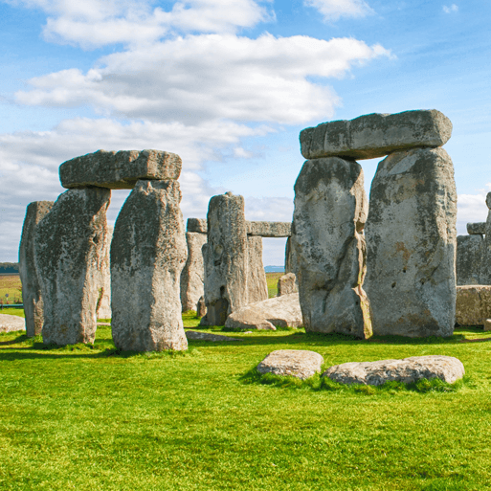  Through the Ages |  |  |   Rock, Relics and Rumbles |  |  |  |  | 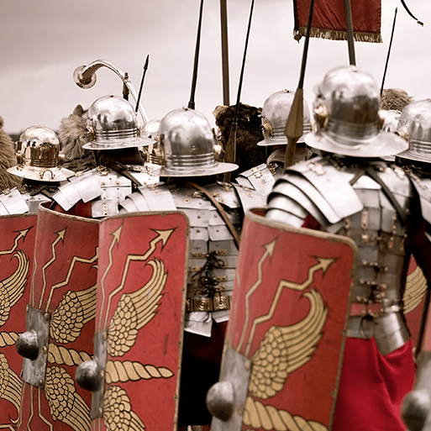  Emperors and Empires
Year 3 | Afternoon read |  | Stig of the Dump |  |  | The Firework-Maker’s Daughter |  |  |  |  | Roman Tales: The Goose Guards
Year 3 | Subject-specific projects | Geog | One Planet, Our World Part 1  Engage/ D1 |  |  | Covered in main project |  |  |  |  | One Planet, Our World Part 2  D2/ Innovate
Year 3 | Subject-specific projects | Science | Animal Nutrition and the Skeletal System |  |  | Rocks and Soil | Forces and magnets |  |  |  | Plant nutrition and reproduction |  |  | Light and Shadows
Year 3 | Subject-specific projects | Art | Colour Theory |  | Prehistoric Pots  Enrichment Day | Ammonite |  |  |  |  | Beautiful botanicals |  |  | Mosaic masters  Enrichment Day
Year 3 | Subject-specific projects | DT |  |  | Cook well, eat well |  |  |  |  | Making It Move |  |  |  | Greenhouse
Year 3 | Subject-specific projects | RE | Sanatana Dharma (Hinduism) |  |  | Christianity |  |  |  |  | Major Festivals
Year 3 | Subject-specific projects | Computing | Connecting Computers |  |  | Stop Frame Animation |  |  |  |  | Sequencing Sounds
Year 3 | Subject-specific projects | Music | Writing music down |  |  | Compose using your imagination |  |  |  |  | Enjoying Improvisation
Year 3 | Subject-specific projects | Spanish | I am learning Spanish | Animals |  | Instruments |  |  | I know how… |  | Fruits
Year 3 | Subject-specific projects | PE | Ball skills /  Fundamentals | Basketball /  Gymnastics |  | Golf /  Dance |  | Tennis /  Dodgeball |  |  | Rounders /  Fitness | Y3 Swimming /  Athletics
Year 3 |  | PSHE | Me and My Relationships | Valuing Difference |  | Keeping Safe |  | Rights and Respect |  |  | Being my Best | Growing and Changing
Year 3 |  | Forest School | Thursday morning: 9-10.30am

Year 4/5 | Driver project |  | 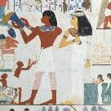  Ancient Civilisations |  |  |  | 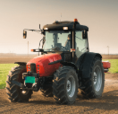  Sow, Grow and Farm |  |  |  | 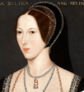  Off with her head!
Year 4/5 | Afternoon read |  | Secrets of a Sun King |  |  |  | The Secret Garden |  |  |  | Treason
Year 4/5 | Subject-specific projects | Geog | Interconnected World Part 1  Engage/ D1 |  |  |  | Covered in main project |  |  |  | Interconnected World Part 2  D2/ Innovate
Year 4/5 | Subject-specific projects | Science | Properties and changes of materials |  |  |  | Human Reproduction and Aging |  |  |  | Grouping and Classifying
Year 4/5 | Subject-specific projects | Art | Statues, Statuettes and Figurines  Enrichment Day |  |  | Islamic Art | Light, Line and Shadows |  |  | Nature’s Art |  |  | Expression
Year 4/5 | Subject-specific projects | DT | Tomb Builders |  |  |  |  |  |  | Eat the Seasons |  |  | Moving Mechanisms
Year 4/5 | Subject-specific projects | RE | Islam |  |  |  | Sikhi (Sikhism) |  |  |  | Humanism
Year 4/5 | Subject-specific projects | Spanish | I know how… | Fruits/Vegetables |  |  | Presenting Myself |  | Family |  | At the Cafe
Year 4/5 | Subject-specific projects | Computing | The Internet |  |  |  | Creating Media: Photo Editing |  |  |  | Selection in Physical Computing
Year 4/5 |  | PE | Hockey  Dance |  | Basketball /  Gymnastics  Y5 Swimming |  | Netball /  Fitness  Y5 Swimming | Dodgeball /  Gymnastics  Y4 Swimming |  |  | Rounders /  Fitness  Y4 Swimming | Athletics /  OAA
Year 4/5 |  | Music | Musical Structures |  |  |  | Composing and Chords |  |  |  | Battle of the Bands
Year 4/5 |  | PSHE | Me and My Relationships |  | Valuing Difference |  | Keeping Safe | Rights and Respect |  |  | Being my Best | Growing and Changing
Year 4/5 |  | Forest School |  |  |  |  | Y4 Thursday morning: 9-10.30am | Year 5 Thursday morning: 9-10.30am  Year 4/5 Thursday morning: 1.10-3.10pm

Year 6 | Driver project |  | 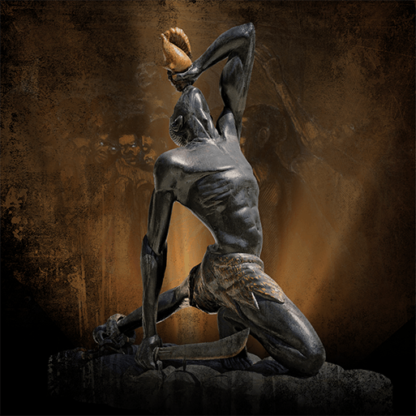  Maafa (The Kingdom of Benin) |  |  |  | 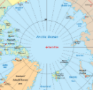  Our Changing World |  |  |  | 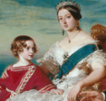  Revolution
Year 6 | Afternoon read |  | Freedom |  |  |  | The Call of the Wild |  |  |  | The Wolves of Willoughby Chase
Year 6 | Subject-specific projects | Geog | Our Changing World Part 1  Engage |  |  |  | Covered in main project |  |  |  | Our Changing World Part 2  D1
Year 6 | Subject-specific projects | Science | Forces and Mechanisms |  |  | Light theory | Properties and Changes of Materials |  |  |  | Electrical Circuits and Components
Year 6 | Subject-specific projects | Art | Trailblazers, Barrier Breakers |  |  |  |  |  |  | Environmental Artists |  | Prints and Provocateurs
Year 6 | Subject-specific projects | DT |  |  |  | Moving Mechanisms | Food for Life |  |  |  | Engineer
Year 6 | Subject-specific projects | RE | Judaism |  |  |  | Buddhism |  |  |  | Christianity
Year 6 | Subject-specific projects | Spanish | Presenting Myself | My family |  |  | The date |  | Do you have a pet? |  | My home
Year 6 | Subject-specific projects | Music | Music and Technology |  |  |  | Developing ensemble skills |  |  |  | Musical Styles
Year 6 | Subject-specific projects | Computing | Communication and Collaboration |  |  |  | Web Page Creation |  |  |  | Variables in Games
Year 6 | Subject-specific projects | PE | Football /  Swimming |  | Netball /  Dance |  | Hockey /  Gymnastics | Dodgeball /  Fitness |  |  | Cricket /  Badminton |  | Athletics /  Rounders
Year 6 |  | PSHE | Me and My Relationships |  | Valuing Difference |  | Keeping Safe | Rights and Respect |  |  | Being my Best |  | Growing and Changing
Year 6 |  | Forest School | Afternoon session: 1.10-3.10pm |  |  |  | Afternoon session: 1.10-3.10pm |  |  |  |  |  | Morning session: 9-10.30am

